Methodocracy Business Plan

Contents

Executive Summary 3

Organizational Structure 4

Objectives 4

Product 5

Benefits 5

Description 5

Knowledge Base 6

The Merit Scale for Arguments 6

GitHub and License 6

Future Development 6

Marketing Plan 6

Market Definition 6

Trends 8

Need 9

Distribution Channels 9

Promotional Efforts 9

Projected Number of Clients 9

Costs and Projected Excess or Earned Income 10

Operational Plan 10

Location of facility 10

Inventory 10

Management and Organizational Team 10

Major Milestones 10

Timeline 10

Capitalization 10

Financial Plan 11

Startup Expenses 11

Break-Even Analysis 12

Five-Year Financial Projection 13

Considerations 13

Appendix 13

# Executive Summary

# Organizational Structure

Board of Trustees

Zachary Hebert

CEO/CTO/CFO

Web Developer

As a startup we believe in starting with something small then expanding later. With the type of work we are doing we don’t even need an office for a while. When the green light turns on we will be operating with two staff, as pictured in the diagram above. The relationship between the two will be similar to when a client hires a web developer to design their website.

## Objectives

* Secure more funding that will allow us to expand

Plans for expansion would be to hire a CFO and grant writer as well as another web developer, as pictured in the diagram below.

Board of Trustees

Zachary Hebert

CEO/CTO

CFO

Grant Writer

Web Developer

Web Developer

# Product

## Benefits

* Supports governmental and non-governmental decision making
* Attempts to solve the world's biggest problems, as well as smaller problems
* Applies metrics and program evaluation to complex social systems

## Description

If you want to advocate for a certain position, such as addressing poverty, you would state your arguments on the site. If you back up your arguments with rigorous scientific research, then your arguments get weighted more heavily. If you just state an opinion with no research or any facts at all, then that gets weighted the least, and is put further down in a hierarchy of arguments for and against that particular topic.

However, no one should entirely dismiss an opinion, as it may contain truths that have yet to be validated by research. After all, Einstein's theory of relativity started out as just a thought, with no research to back it up.

Anyone can propose arguments on any subject, and ideally, this site could be useful when determining the best course of action in setting policy within governmental entities, political initiatives, scientific endeavors, nonprofit initiatives, corporate actions -- well, just about anything! Perhaps it could also centralize scientific publication.

There is something missing on the Internet, its true potential has yet to be unlocked.

The following two sections go into detail on how Methodocracy works.

## Knowledge Base

Users browse, search, and submit arguments into the knowledge base. These arguments attempt to either disprove or support other arguments. This debate-like structure is the fundamental philosophy of the system, and its principles can be applied to more tasks that are necessary for problem-solving. For example, sometimes it will be debated whether an argument disproves or supports another argument. At that point, the debate surrounding that connection has its own subsection of arguments attempting to disprove and support each other. To use another example, peer review, which is necessary for increasing the merit of an argument, may be disproven itself, meaning that it wasn't a thorough review of the material

## The Merit Scale for Arguments

Certain kinds of arguments hold more merit than others. One problem with today's scientific method is that it almost entirely utilizes the most meritable methods of debate, putting less emphasis on all other discussions that could potentially hold merit. Methodocracy attempts to utilize productivity from all arguments by ranking them in a merit scale. The most meritable methods for making an argument still hold the most weight, and less meritable arguments hold less weight. A less meritable argument could inspire a more meritable one, and if a lot of less meritable arguments are in a debate, a more meritable argument could be used to settle it.

For example, a controlled experiment is the most meritable. Under that is observational studies. Somewhere in the middle is a research report compiled from multiple sources, under that is a logical thought process paper, under that is an idea, and at the very bottom is a comment and an opinion. When users search the knowledge base, the most meritable arguments will appear first. This ensures that at the end of the day, we value truth. The less meritable arguments will aid us in discovering the higher truths faster, as this allows more people to contribute to the process.

A list of frequently asked questions and answers has been provided in the appendix.

## GitHub and License

Almost all files are open-sourced. They are on GitHub and are shared under the GNU General Public License or GNU Free Documentation License.

## Future Development

* Determine how each type of argument in the academic world rates on the merit scale
* Break down each of these arguments into their parts for the website forms (Drop-down menus, checkboxes, etc.)
* Create an interactive experience
* Test the system rigorously as a science using metrics and visualization of data and decide which direction to proceed

# Marketing Plan

## Market Definition

We believe our constituency is very similar to the constituency of Wikipedia. This is because, for a website run by a nonprofit and with similar values, it is the most popular in the Alexa top 500 websites ranking list. Market data and demographics from Wikipedia’s Editor Survey 2011 will be used for Methodocracy.

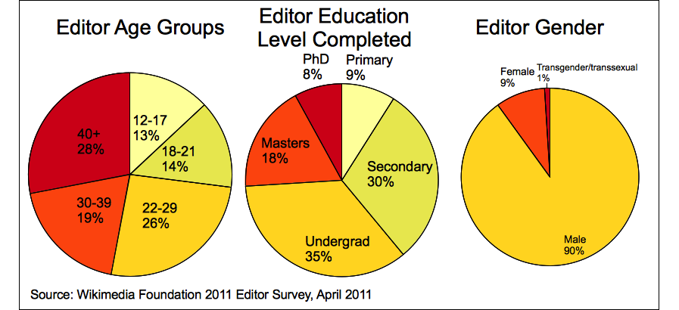

Wikipedia Editor survey demographic breakdown

According to the Editor Survey 2011: “Most of our editors still reside in Europe and North America.”

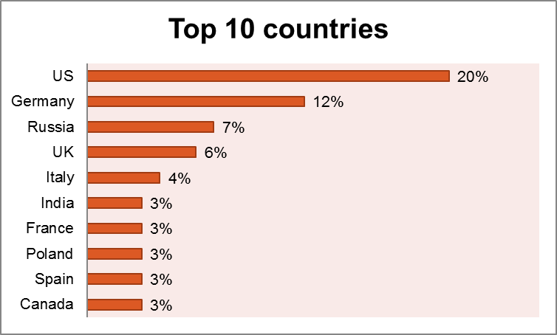

Percent who live in the following countries.

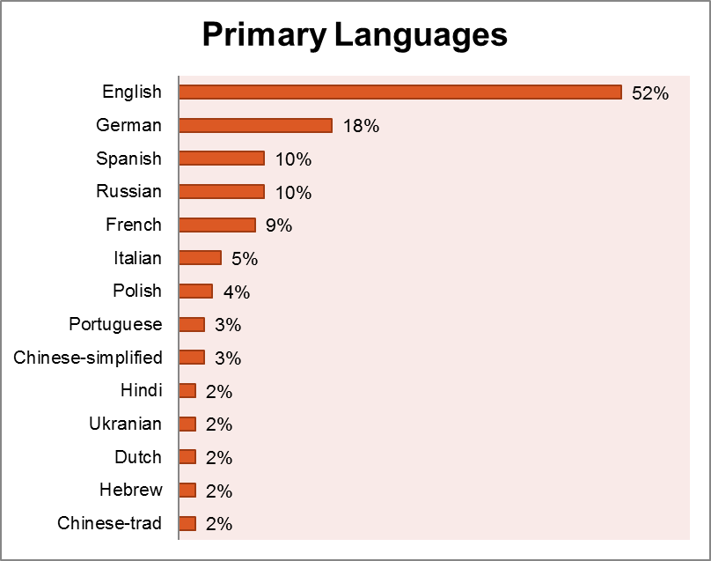

Percent whose primary language(s) are listed.

The core constituency is an English-speaking American male. He is either between the ages of 22 and 29 and is either working on his undergraduate degree or is finished, or he is aged 40 or higher with a finished degree or sometimes without one.

Note that although the data shows most Wikipedians are males, Methodocracy will target both males and females equally.

## Trends

To quote the Wikipedia article about the Wikipedia Community: “As of October 2013, the community of volunteers [declined at least by a third since 2007](http://en.wikipedia.org/wiki/Wikipedia#Decline_in_participation_since_2007) and is continuing to drop”

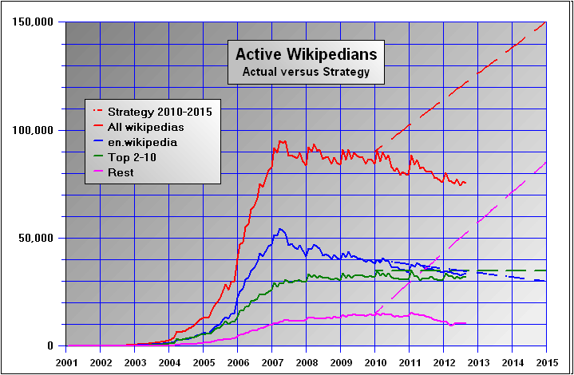

Historical chart of the number of Wikipedians considered as active by the Wikimedia Foundation

## Need

* There is no centralized environment for opinionated ideologies to debate using evidence so that we may glean truth from any of them.
* There’s not enough data analytics and performance metrics in policy making and policy review. Evidence-based research can start the process, which can lead to better performance management.
* There is no way to see how many times an argument has been reproduced in history unless it was published as an academic paper. Even then, the metrics on it would be somewhat disorganized and decentralized.
* All problem-solving results will be readily available. A knowledge base of this caliber does not exist.

## Distribution Channels

Direct access to website, search engines, links from other sites, links to a specific argument.

## Promotional Efforts

Kickstarter will be used to attract attention to Methodocracy on launch and secure an active user base right off the bat. Funding from Kickstarter will count as the public support clause enforced by the IRS.

## Projected Number of Clients

Using graph No. XX, it can be projected that Methodocracy will reach 70,000 active users after 12 years. The number of active users will remain under 10,000 for 3 years.

## Costs and Projected Excess or Earned Income

About $15,000 in costs for the explainer video on Kickstarter. As for income, a variable amount depending on how far donors surpass the target goal, and the level the target goal is set.

# Operational Plan

## Location of facility

There will not be a facility at first. All work can be done from home.

## Inventory

* 2 Computers
* 1 publically-shared server

# Management and Organizational Team

Currently, the only individual on the management team is the prospective CEO, Zachary Hebert. Zachary’s principles are to lead an effective organization through delegation and trust, paced review of programs, introduction of data collection and visualization, and promoting a relaxed and fun working atmosphere. Zachary is going to school for computer science and is versed with C++. He has a history with making video games as a hobby, and organizing people together for social groups within gaming communities.

# Major Milestones

1. Build a working prototype

Create a framework and user experience that gets the job done, a point where things can progressively be improved upon.

1. Improve the framework and user experience so that problems can be effectively solved

Continue adding types of arguments and rating them on the merit scale. Break up arguments into interactive forms (Drop-down menus, checkboxes, etc.) and assign properties to each of them. Add new features that are focused on getting to the next milestone.

1. Solve smaller, manageable problems in local communities

Show that problems can be solved using Methodocracy by doing some work in the field.

## Timeline

Timeline starts with launch of company, and extends to periods after that point.

#1 – 6 months

#2 – 1 year

#3 – 1 year

# Capitalization

No equity will be able to be held in the company due to its 501(c)(3) status. This means there is no capital structure. There are no outstanding loans, debts, holdings, bonds or endowments. There are no subsidiary relationships.

# Financial Plan

## Startup Expenses

A Statement of Financial Activities is used to calculate the startup expenses for the first year.

|  |  |  |  |  |
| --- | --- | --- | --- | --- |
| **Statement of Financial Activities** | | | | |
| **Methodocracy Foundation, Year Ending in 2015** | | | | |
| Changes in Unrestricted Net Assets: | Unrestricted | Temporarily | Permanently | Total |
| restricted | restricted |
| **Revenues and Gains:** |  |  |  |  |
| Public Contributions | $ - | $ - | $ - | $ - |
| Program Service Revenue: | $ - | $ - | $ - | $ - |
| Investment Income: | $ - | $ - | $ - | $ - |
| Net Assets Released from Restrictions: | $ - | $ - | $ - | $ - |
| **Total Revenues, Gains, Other Support: (A)** | $ - | $ - | $ - | $ - |
|  |  |  |  |  |
| **Expenses:** |  |  |  |  |
| Program Services: | $ - | $ - | $ - | $ - |
| Salaries and Wages | $ 130,000.00 | $ - | $ - | $ 130,000.00 |
| Employee Benefits | $ 54,488.00 | $ - | $ - | $ 54,488.00 |
| Payroll Taxes | $ 35,341.19 | $ - | $ - | $ 35,341.19 |
| Insurance | $ 15,000.00 | $ - | $ - | $ 15,000.00 |
| Rent | $ - | $ - | $ - | $ - |
| Utilities | $ - | $ - | $ - | $ - |
| Depreciation and Amortization | $ 200.00 | $ - | $ - | $ 200.00 |
| Office supplies | $ - | $ - | $ - | $ - |
| Travel and entertainment | $ - | $ - | $ - | $ - |
| Postage | $ - | $ - | $ - | $ - |
| Equipment maintenance and Rental | $ 2,400.00 | $ - | $ - | $ 2,400.00 |
| Interest | $ - | $ - | $ - | $ - |
| Furniture and equipment | $ 1,600.00 | $ - | $ - | $ 1,600.00 |
| Marketing | $ - | $ - | $ - | $ - |
| Fund raising: | $ 10,000.00 | $ - | $ - | $ 10,000.00 |
| **Total Expenses and Losses: (B)** | $ 249,029.19 | $ - | $ - | $ 249,029.19 |
|  |  |  |  |  |
| **Increase in Net Assets: (C = A-B)** | $ (249,029.19) | $ - | $ - | $ (249,029.19) |
| Net Assets as Beginning of Year: (D) | $ - | $ - | $ - | $ - |

So a net expense for the first year being $249,029.19 plus a one-year operating reserve to give a total of $496,658.38 for required startup capital. Note that after the first year, almost no capital is needed for the operating reserve, so the total expenses for year two will be at least $247,269.19.

## Break-Even Analysis

* Q – Quantity. This represents the number of clients served.
* CI – Contributed Income. These are subsidy dollars, such as grants and individual contributions that do not vary when service levels change.
* EI – Earned Income. These dollars vary in direct proportion to the number of clients served.
* P – Price. Synonymous with variable income, this is the amount of revenue we receive for each client served.
* FC – Fixed Costs. These expenses do not at all vary with the number of clients served.
* VC – Variable Costs. These are expenses that vary as the number of clients served varies.

Again, information about Wikipedia is used to find the “P” price shown above. According to the Fundraising/2013-14 Report Wikipedia article, the average donation size was $15.

Break-even analysis for startup expenses:

Cl + El > TFC(Total VC) + TVC(Total VC)

Cl + (Q*P) > TFC + (Q*VC)

331,105.58 + (Q*15) > 249,029.19 + (Q*0)

Q*15 > -82,076.39

Q > -5,471.76

(Q > 0)

Even though the break-even point is effectively at zero, startup capital still needs to be raised by the public in order to satisfy the public support clause for the IRS. This will be done using Kickstarter. The amount needed to be raised is $165,552.79 and that averages out to be 11,037 contributors.

Break-even analysis for year two, projected at minimum expenses:

Cl + El > TFC(Total VC) + TVC(Total VC)

Cl + (Q*P) > TFC + (Q*VC)

165,086.12 + (Q*15) > 247,629.19 + (Q*0)

Q*15 > 82,543.07

Q > 5,503

## Five-Year Financial Projection

# Considerations

# Appendix

## Appendix I - License

Copyright 2014-2015 Zachary Hebert, Patrick Gillespie

This is part of the Methodocracy Documentation.

Permission is granted to copy, distribute and/or modify this document under the terms of the GNU Free Documentation License, Version 1.3 any later version published by the Free Software Foundation; no Invariant Sections, no Front-Cover Texts, and no Back-Cover Texts. A copy of the license is included in the section entitled "GNU Free Documentation License".

Methodocracy TM is a trademark of Methodocracy.org (C)2014-2015, and all rights to that TM are reserved. Any modified versions are required to be marked as changed, so that their problems will not be attributed erroneously to authors of previous versions. And the name Methodocracy TM should be clearly labeled as the source of your work as long as any part of this work remains intact in part or in whole.